***Tiingo API***

**OTHER FEATURES TAB?**

1. Senate
2. Crypto
3. etc

**DIVIDEND/EARNING/STATEMENT ANALYSIS TABS?**

Quartely info only. Worth it???



Stock price data: DONE

***Financial Modelling Prep API***

**MARKET PERFORMANCE TAB**

1. Sector historical: DONE
2. Market Index
3. Sector PE ratio: DONE

**COMMODITIES TAB**

1. Commodities daily: figure out which commodities (gold etc) matter for the tech stocks in question and pull data on them: DONE

**FOREX TAB**

1. Forex daily: figure out which currencies relative to USD matter for the tech stocks in question and pull data on them: DONE

**NEWS TAB**

1. Stock news: DONE
2. Press release news: DONE
3. Historical social sentiments: DONE

**ECONOMICS DATA TAB**

1. Treasury rates: DONE
2. Economic indicators – inflation rate: DONE

**TECHNICAL INDICATORS TAB**

1. SMA, EMA, Bollinger bands etc.
2. Figure out which indicators work best for our tech stocks and pull data on them and possibly combine them in one excel file: DONE

**DATASETS MERGING**

1. Combine all datasets (stock price, news, forex, market performance, commodities etc) by date for each company separately. All date formats across different datasets should match.
2. Include Nvidia features (exact features to be determined) into each company’s final dataset.

**MODEL ESTIMATIONS**

1. First attempt on LSTM model
2. Other attempts on models including the Random Forest, GRU and Black-Scholes model
3. Ensemble models
4. Evaluating and comparing models

**MARKET PERFORMANCE TAB**

1. Combine data into one excel file for each company

**NEWS TAB**

1. Aggregate each news type to daily data: DONE
2. Merge all 3 types to composite score? : DONE

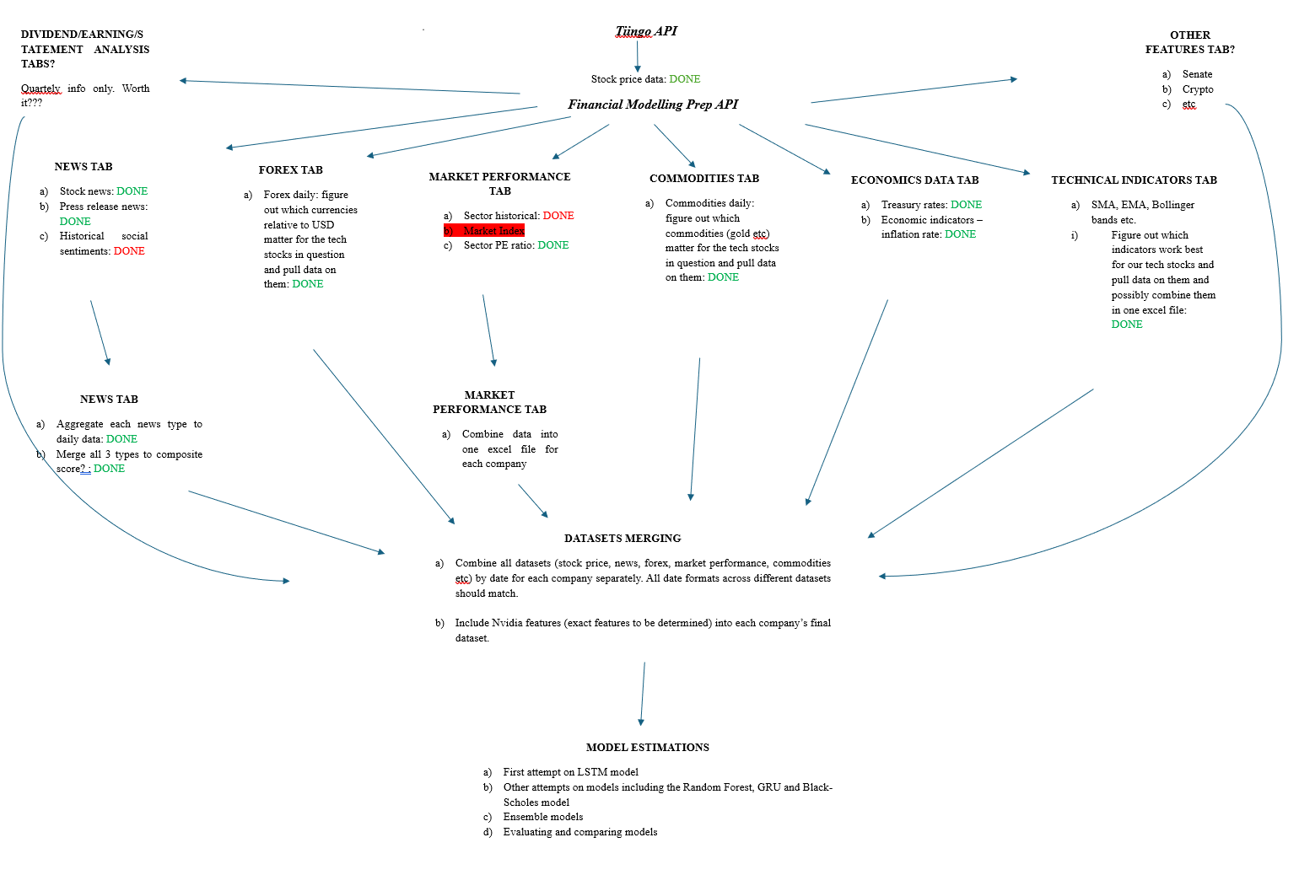

**DATASETS REQUIRED FOR EACH COMPANY**

1. Stock price datasets.
2. Merged technical indicators.
3. Complete news data (includes news, press releases and social sentiments).
4. Forex datasets.
5. Commodity datasets.
6. Treasury rates dataset
7. Inflation rates dataset
8. Sector_pe_ratio dataset
9. Historical_sector_performance dataset.